**[Laboratory No. 2.3:** **Piglatin]**

**Objectives:**

1. To know the loop construct in Python Programming
2. To create a program that take advantage of the loop mechanisms

**Materials:**

1. PC or Laptop
2. Python Package Development Kit
3. Pycharm or any IDE

**Background**

**String** literals in python are surrounded by either single quotation marks, or double quotation marks.

**'hello'**is the same as **"hello".**

You can display a string literal with the **print()** function:

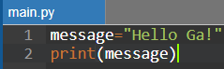

***Output:***



**Strings as Arrays**

Like many other popular programming languages, strings in Python are arrays of bytes representing Unicode characters.

However, Python does not have a character data type, a single character is simply a string with a length of 1. **Square brackets** can be used to access elements of the string.

**Example:** Get the character at position 1 (***remember that the first character has the position 0***):

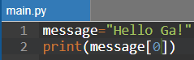

***Output:***



**Example:** Get the character at position from 0 to 5

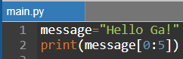

***Output:***



**Example:** Get the rest of the characters starting at 5 ***(Line 2)***. And all characters up to 10 ***(Line3)***.

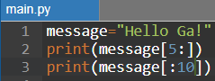

***Output:***



**Example:** Another example showcasing some of the functions in String.

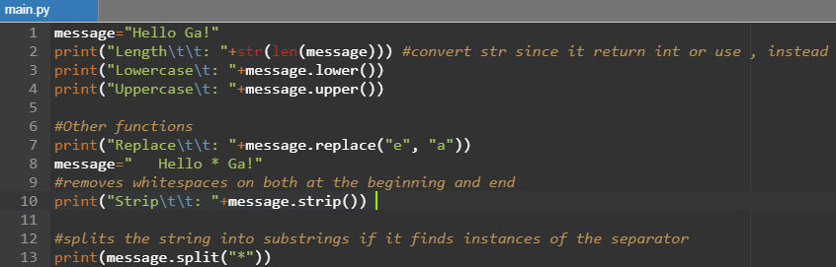

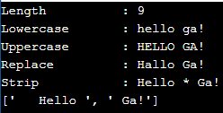

**Example:** A string example using **in** operator to find a character

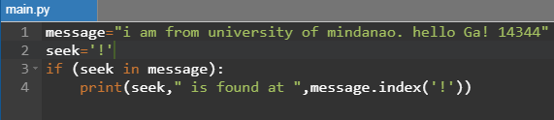



**Here is a complete list of String functions**

|  |  |
| --- | --- |
| **Method** | **Description** |
| [capitalize()](https://www.w3schools.com/python/ref_string_capitalize.asp) | Converts the first character to upper case |
| [casefold()](https://www.w3schools.com/python/ref_string_casefold.asp) | Converts string into lower case |
| [center()](https://www.w3schools.com/python/ref_string_center.asp) | Returns a centered string |
| [count()](https://www.w3schools.com/python/ref_string_count.asp) | Returns the number of times a specified value occurs in a string |
| [encode()](https://www.w3schools.com/python/ref_string_encode.asp) | Returns an encoded version of the string |
| [endswith()](https://www.w3schools.com/python/ref_string_endswith.asp) | Returns true if the string ends with the specified value |
| [expandtabs()](https://www.w3schools.com/python/ref_string_expandtabs.asp) | Sets the tab size of the string |
| [find()](https://www.w3schools.com/python/ref_string_find.asp) | Searches the string for a specified value and returns the position of where it was found |
| [format()](https://www.w3schools.com/python/ref_string_format.asp) | Formats specified values in a string |
| format_map() | Formats specified values in a string |
| [index()](https://www.w3schools.com/python/ref_string_index.asp) | Searches the string for a specified value and returns the position of where it was found |
| [isalnum()](https://www.w3schools.com/python/ref_string_isalnum.asp) | Returns True if all characters in the string are alphanumeric |
| [isalpha()](https://www.w3schools.com/python/ref_string_isalpha.asp) | Returns True if all characters in the string are in the alphabet |
| [isdecimal()](https://www.w3schools.com/python/ref_string_isdecimal.asp) | Returns True if all characters in the string are decimals |
| [isdigit()](https://www.w3schools.com/python/ref_string_isdigit.asp) | Returns True if all characters in the string are digits |
| [isidentifier()](https://www.w3schools.com/python/ref_string_isidentifier.asp) | Returns True if the string is an identifier |
| [islower()](https://www.w3schools.com/python/ref_string_islower.asp) | Returns True if all characters in the string are lower case |
| [isnumeric()](https://www.w3schools.com/python/ref_string_isnumeric.asp) | Returns True if all characters in the string are numeric |
| [isprintable()](https://www.w3schools.com/python/ref_string_isprintable.asp) | Returns True if all characters in the string are printable |
| [isspace()](https://www.w3schools.com/python/ref_string_isspace.asp) | Returns True if all characters in the string are whitespaces |
| [istitle()](https://www.w3schools.com/python/ref_string_istitle.asp) | Returns True if the string follows the rules of a title |
| [isupper()](https://www.w3schools.com/python/ref_string_isupper.asp) | Returns True if all characters in the string are upper case |
| [join()](https://www.w3schools.com/python/ref_string_join.asp) | Joins the elements of an iterable to the end of the string |
| [ljust()](https://www.w3schools.com/python/ref_string_ljust.asp) | Returns a left justified version of the string |
| [lower()](https://www.w3schools.com/python/ref_string_lower.asp) | Converts a string into lower case |
| [lstrip()](https://www.w3schools.com/python/ref_string_lstrip.asp) | Returns a left trim version of the string |
| maketrans() | Returns a translation table to be used in translations |
| [partition()](https://www.w3schools.com/python/ref_string_partition.asp) | Returns a tuple where the string is parted into three parts |
| [replace()](https://www.w3schools.com/python/ref_string_replace.asp) | Returns a string where a specified value is replaced with a specified value |
| [rfind()](https://www.w3schools.com/python/ref_string_rfind.asp) | Searches the string for a specified value and returns the last position of where it was found |
| [rindex()](https://www.w3schools.com/python/ref_string_rindex.asp) | Searches the string for a specified value and returns the last position of where it was found |
| [rjust()](https://www.w3schools.com/python/ref_string_rjust.asp) | Returns a right justified version of the string |
| [rpartition()](https://www.w3schools.com/python/ref_string_rpartition.asp) | Returns a tuple where the string is parted into three parts |
| [rsplit()](https://www.w3schools.com/python/ref_string_rsplit.asp) | Splits the string at the specified separator, and returns a list |
| [rstrip()](https://www.w3schools.com/python/ref_string_rstrip.asp) | Returns a right trim version of the string |
| [split()](https://www.w3schools.com/python/ref_string_split.asp) | Splits the string at the specified separator, and returns a list |
| [splitlines()](https://www.w3schools.com/python/ref_string_splitlines.asp) | Splits the string at line breaks and returns a list |
| [startswith()](https://www.w3schools.com/python/ref_string_startswith.asp) | Returns true if the string starts with the specified value |
| [strip()](https://www.w3schools.com/python/ref_string_strip.asp) | Returns a trimmed version of the string |
| [swapcase()](https://www.w3schools.com/python/ref_string_swapcase.asp) | Swaps cases, lower case becomes upper case and vice versa |
| [title()](https://www.w3schools.com/python/ref_string_title.asp) | Converts the first character of each word to upper case |
| translate() | Returns a translated string |
| [upper()](https://www.w3schools.com/python/ref_string_upper.asp) | Converts a string into upper case |
| [zfill()](https://www.w3schools.com/python/ref_string_zfill.asp) | Fills the string with a specified number of 0 values at the beginning |

**Source:** <https://www.w3schools.com/python/python_ref_string.asp>

**Instructions:**

1. Create class **Piglatin*[Surname]***
2. **Problem Scenario**

**“Pig Latin”** is used to obscure regular English words. To translate from English to Pig Latin, use the following rules:

* Words that **begin with a vowel (a,e,i,o,u)** should have string **“ay”** (not including the quotes) added after it.

*For example*, “apple” becomes “appleay”.

* Words that begin with a consonant should have the first consonant moved to the end of the word, and then “ay” should be added after the word.

*For example*, “hello becomes “ellohay”

Write a program to translate English words to Pig Latin.

1. **Input**

The input consists of a ***single word***, consisting only of **lowercase English letters**. The word will **be at least 3 and at most 10 characters** long.

1. **Constraints**

Words should NOT contain digits, special characters, null or empty values.

1. **Output**

Output a single line containing the Pig Latin Translation of that word.

**Sample input #1 Sample output #1**

tomato omatotay

**Sample input #1 Sample output #1**

umbrella umbrellaay

**Sample input #1 Sample output #1**

oregano oreganoay

**Sample input #1 Sample output #1**

tomato omatotay

**Sample input #1 Sample output #1**

yellow ellowyay

1. **Source Codes**

|  |
| --- |
|  |

1. **Sample Input/Output**

**NOTE: Provide a screenshot and describe your observation for each action you performed based on the item below:**

* **Input “University” as value**
* **Input “University of Mindanao”**
* **Input “GLORY”**
* **Input “GOT”**
* **Input empty string**
* **Input any numerical value**

1. **Submit your file with filename convention:Piglatin*[Surname]***

**Rules:**

1. Each laboratory activity has time limit of 1:30 minutes and is due on the day depending on the level of difficulty or constraints.
2. Each activity will only last every after 3 days and has deduction of 10 points every day from the day it was given.